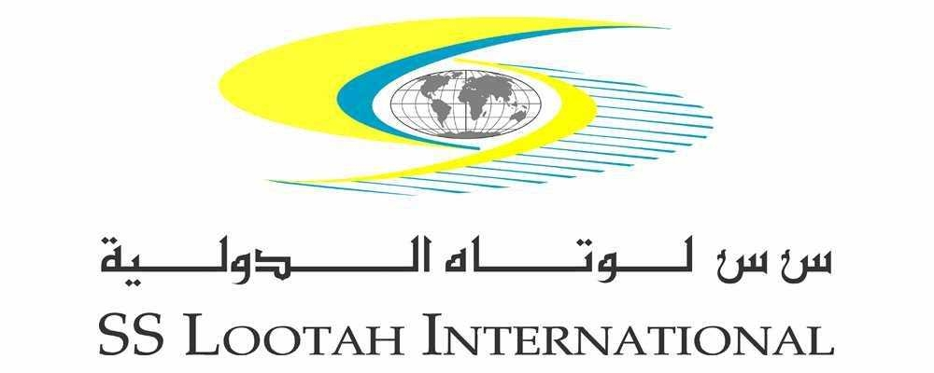

S.S. Lootah International
Regional Edge. Global Reach

S.S. Lootah International was envisioned in 1997, and subsequently established as the international business arm of S. S. Lootah Group leading its national, regional and global business growth in the 21st century. S.S. Lootah International business philosophy reflects Dubai’s dynamism through pioneering successful projects that is critical to the needs of economic development. Besides being a unique business expertise and know-how exchange platform, our international ventures facilitate knowledge creation that addresses pressing issues and global challenges.

Today, S. S. Lootah International has become the name behind multi billion dollar projects in markets that cater to over 3 billion people, stretching over Asia, Africa and Europe. Over the past years, our successful alliances, partnerships and joint ventures with leading international companies have enabled us to develop, manage, support and finance some of the most sophisticated projects in the construction, industrial, telecommunications, energy, environmental research and sustainable development sectors.

S.S. Lootah International continues to pursue strategic partnerships with leading businesses worldwide to serve the ever growing development needs in our region and beyond, with sustainable projects that benefit the people, economy and future generations

Key Areas of Focus

- Investment
- Joint Ventures
- Project Development
- Project Management
- Feasibility Studies
- Market Analysis

For more information, please log on to www.sslootahinternational.com

