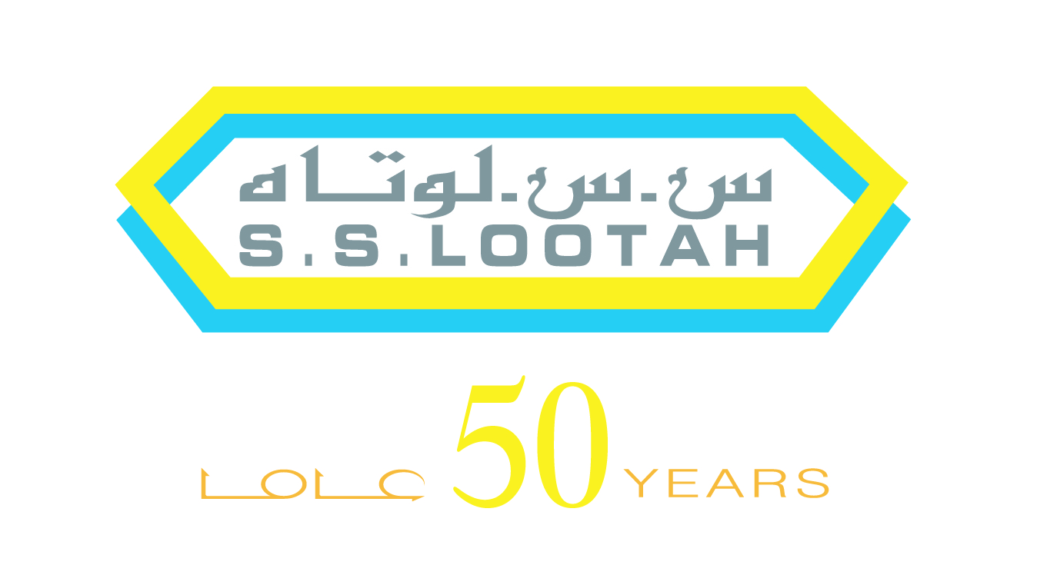
S.S Lootah Group
Inspiring with distinction

Established in Dubai in 1956, S.S. Lootah Group is a family-owned diversified business house with ventures across key industries from Construction, Real Estate, Energy, Food and Hospitality to Financial Services, Applied Research, ICT, Education and Healthcare among others along with a remarkable portfolio of not-for-profit educational institutions.

From the first contracting company and first medical College in the United Arab Emirates to the first Islamic bank in the world, the entrepreneurial spirit of S.S. Lootah Group has been the catalyst that has brought home-grown business and community ventures to the global stage. This extraordinary portfolio carries the hallmark of the visionary Haj Saeed Bin Ahmed Al Lootah, the founder and chairman of S.S. Lootah Group and is driven today by Eng. Yahya Bin Saeed Al Lootah, a strong second generation leader guided by enduring values and global thought and business leadership.

With over 10,000 multinational workforces, entrepreneurship, veracity as well as a profound dedication to corporate citizenship and sustainable development, S.S. Lootah Group is a driving force for national and regional economic growth, progress and innovation in the 21st century.

SECTORS PRESENT IN
- Construction
- Real Estate
- Financial Services
- Energy
- Healthcare
- Trading and Retail
- Engineering

- Architecture
- Interior Design
- Hospitality
- R&D
- ICT
- Media
- Education

For more information, please log on to www.sslootahgroup.com

